**Q1.**

**A company has an API to manage purchase orders, with each record identified by a unique purchase order ID. The API was built with RAML according to MuleSoft best practices.**

**What URI should a web client use to request order P05555?**

A/orders/{P05555}

**Q2.**

**A Database On Table Row listener retrieves data from a CUSTOMER table that contains a primary key userjd column and an increasing kxjin_date_time column. Neither column allows duplicate values.**

**How should the listener be configured so it retrieves each row at most one time?**

BSet the target value to the last retrieved login_date_time value

**Q3.**

**Refer to the exhibits.**

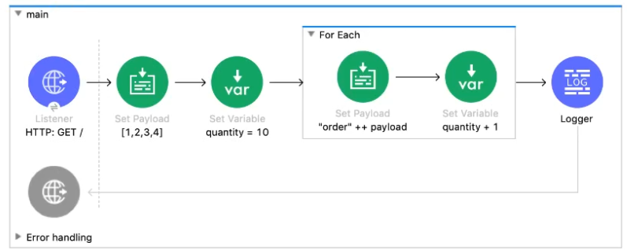

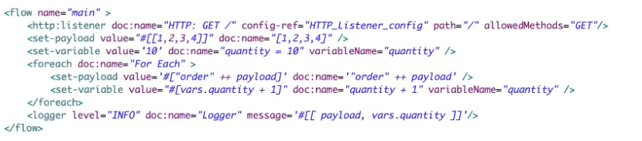

B[[order1, order2, order3, order4], 14]

**Q4.**

**A Mule project contains a DataWeave module called MyModule.dwl that defines a function named formatString. The module is located in the project's src/main/resources/modules folder.**

**What is the correct way in DataWeave code to import MyModule using a wildcard and then call the module's formatString function?**

AOption A

**Q5.**

**Refer to the exhibits.**

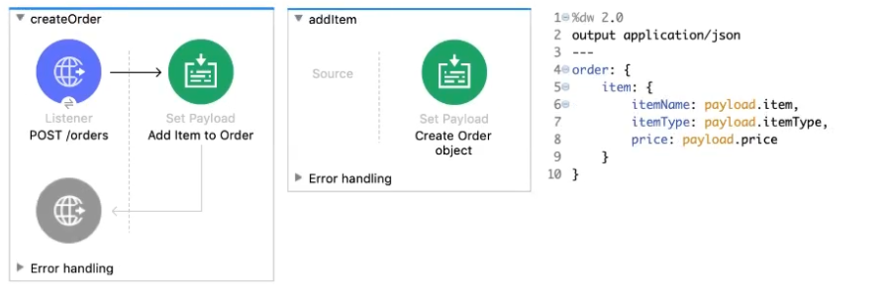

**The Set Payload transformer In the addltem subflow uses DataWeave to create an order object.**

**What is the correct DataWeave code for the Set Payload transformer in the createOrder flow to use the addltem subflow to add a router cable with the price of 100 to the order?**

Blookupf 'addltem', { payload: { price: '100', item: 'router', itemType: 'cable' } } )

What condition requires using a CloudHub Dedicated Load Balancer?

**B**When custom DNS names are required for API implementations deployed to customer-hosted Mule runtimes

Question 2

When designing an upstream API and its implementation, the development team has been advised to not set timeouts when invoking downstream API. Because the downstream API has no SLA that can be relied upon. This is the only donwstream API dependency of that upstream API. Assume the downstream API runs uninterrupted without crashing. What is the impact of this advice?

**C** A default timeout of 500 ms will automatically be applied by the Mule runtime in which the upstream API implementation executes.

Question 3

An API has been updated in Anypoint Exchange by its API producer from version 3.1.1 to 3.2.0 following accepted semantic versioning practices and the changes have been communicated via the API's public portal. The API endpoint does NOT change in the new version. How should the developer of an API client respond to this change?

**D** The API client code ONLY needs to be changed if it needs to take advantage of new features.

Question 4

A new upstream API Is being designed to offer an SLA of 500 ms median and 800 ms maximum (99th percentile) response time. The corresponding API implementation needs to sequentially invoke 3 downstream APIs of very similar complexity. The first of these downstream APIs offers the following SLA for its response time: median: 100 ms, 80th percentile: 500 ms, 95th percentile: 1000 ms. If possible, how can a timeout be set in the upstream API for the invocation of the first downstream API to meet the new upstream API's desired SLA?

**A** Set a timeout of 100 ms; that leaves 400 ms for the other two downstream APIs to complete

Question 5

An organization has several APIs that accept JSON data over HTTP POST. The APIs are all publicly available and are associated with several mobile applications and web applications. The organization does NOT want to use any authentication or compliance policies for these APIs, but at the same time, is worried that some bad actor could send payloads that could somehow compromise the applications or servers running the API implementations. What out-of-the-box Anypoint Platform policy can address exposure to this threat?

* **D**Apply a JSON threat protection policy to all APIs to detect potential threat vectors

Question 6

An organization is implementing a Quote of the Day API that caches today's quote. What scenario can use the CloudHub Object Store connector to persist the cache's state?

**A** When there is one deployment of the API implementation to CloudHub and another one to customer hosted mule runtime that must share the cache state.

Question 7

An organization is evaluating using the CloudHub shared Load Balancer (SLB) vs creating a CloudHub dedicated load balancer (DLB). They are evaluating how this choice affects the various types of certificates used by CloudHub deployed Mule applications, including MuleSoft-provided, customer-provided, or Mule application-provided certificates. What type of restrictions exist on the types of certificates for the service that can be exposed by the CloudHub Shared Load Balancer (SLB) to external web clients over the public internet?

**B**Only MuleSoft provided certificates can be used for server side certificate

Refer to the exhibit. What are the values of the counter and stepVar variables in the On Complete phase?

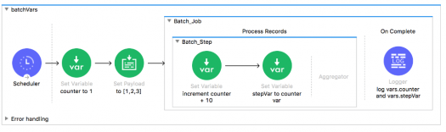



Counter: 1, stepVar: null

What MuleSoft product enables publishing, sharing, and searching of APIs?



Anypoint Exchange

Refer to the exhibit. What are the values of the counter and stepVar variables after the Batch Job?

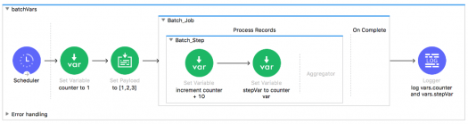



Counter: 1, stepVar: null

A Batch Job scope has three batch steps. An event processor in the second batch step throws an error because the input data is incomplete. What is the default behavior of the batch job after the error is thrown?



All processing of the batch job stops

Refer to the exhibits. What is the output of the Logger component in the Batch Job?

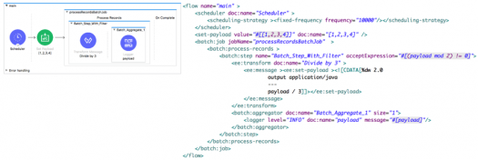

In a RAML specification, what attribute defines a query parameter to be optional for a resource?



Required: false

What is NOT part of a Mule 3 message?



Variables

What out-of-the-box policy can safeguard against Denial of Service type attacks?



Rate limiting

A Mule application properties file named training-DEVproperties has been defined. How is the properties file referenced in the Mule application?



In a Property Placeholder element

What port number is used to expose the domain URL of a Mule application deployed to CloudHub?



8081

What message processor can set the HTTP response status code to 200?



Set Payload

What property of a Mule message is immutable?



InboundProperties

A Mule application has two flows named parentFlow and childFlow. A variable is defined in parentFlow. What is true for a Mule subflow?

What is the default processing strategy of a one-way flow?



Queued-asynchronous

What is required for two Mule applications to share data using a VM connector component?



Put the Mule applications in the same non-default Mule domain

How are outbound properties automatically passed to an outbound REST request using an HTTP Request component?



As headers

A WSDL defines a conversionRate operation with an input message that requires two parts: fromCurrency and toCurrency. How are fromCurrency and toCurrency set in the flow in order to call the conversionRate operation using a Web Service Consumer component?



In the message payload

What is NOT a way to pass data to a RESTful web service in a flow using an outbound HTTP Request component?



Set inbound properties before the HTTP Request component

What asset can NOT be created using Anypoint Platform Design Center?



API portals

An exception is caught by a choice exception strategy. How is the exception routed?



To the first exception strategy whose condition evaluates to true

How is a default exception strategy set in a Mule application?



In a configuration global element in any Mule configuration XML file

A Payload filter is configured to test for type javalang_String. What happens when the filter is passed a message with the payload null?



All subsequent message processors are skipped

What module and operation will throw an exception if a Mule event's payload is not a number?



Validation module’s Is number operation

A Mule flow has a JMS queue listener as the message source. Where can the next message processor access a JMS messages header?



Inbound property

What part of a Mule flow can contain a Poll scope?



Message source

How is a Poll scope's watermark accessed from a message processor in a flow?



In a flow variable

A File connector configured to read files from a /mule/input directory. All other File connector settings are the default settings. What happens to a file after it is processed by the File connector?



The file is deleted from the input directory, but is not moved anywhere

What phase of a batch job using a Batch scope must contain at least one message processor?



Process Records

A message payload is modified using a Message Enricher scope with an empty target. What is true about the message payload that leaves the Message Enricher scope?



The payload returns to the original payload

A Batch scope has three batch steps. A message processor in the second batch step throws an exception because the input data is incomplete. What is the default behavior after the exception is thrown?



Stops processing the entire batch job

What is the purpose of the api:router element in APIkit?



Validates requests against RAML API specifications and routes them to API implementations

What is the scope of a record variable in a Batch scope?

A web client submits a GET request to a Mule 4 application to the endpoint /customers?id=48493. Where is the id stored in the Mule event by the HTTP Listener?



Attributes

Assume that a database table contains a record ID column that always increases as new records get added to the table. In a Mule application, what is the key process to enable manual watermarking for requests to a database using the Scheduler endpoint and the Database SELECT operation?

How is the success of a Center for enablement measured?



Measured on accessibility of assets

1. What are four ways APIs provide the info for how to communicate with a software component? (Select 4... lol)

This defines what you can call, what you send it, and what you get back:



Web Service

An API has been created in Design Center. What is the next step to make the API discoverable?



Publish the API to Anypoint Exchange

What is an application that controls access to a web service, restricting access and usage with an API gateway?



API Proxy

What is the actual implementation you can make calls to or the interface of that API implementation?

How are SOAP web services defined?



In an XML-based WSDL (Web Services Description Language) file

In what file does the Mule project keep track of all of its dependencies?



Pom.xml

What do RESTful web services use?



Existing HTTP communication protocol

What is the minimum required configuration in a flow for a Mule application to compile?



An event processor/A message processor in the Process section of a flow

What can ONLY be done with VM connectors, and NOT with Flow References, in a single Mule application?

Which RESTful web service request method partially updates a resource?



PATCH

Which RESTful web service request method creates a new resource?



PUT

An inbound Database connector is configured to select rows from a MySQL database. What is the format of results returned from the database query?

Which RESTful web service request method deletes a resource?



DELETE

What is NOT part of a Mule 4 event?



InboundProperties

What file type is required to configure a Web Service Consumer to consume a SOAP web service?



WSDL

How does APIkit determine the number of flows to generate from a RAML specification?



Creates a separate flow for each HTTP method

How are query parameters dynamically passed to an outbound REST request using an HTTP Request operation?

As query parameters in the HTTP Request operation

What is the purpose of API autodiscovery?

Allows the Mule application to be automatically discovered on Anypoint Exchange

Refer to the exhibit: #%RAML 1.0 title: ACME Medical API baseUri: https://dev.acme.com/api /patients: GET: queryParamet ers: year: type: integer example: 2017 What is the correct URL to perform a GET request to /patients?

<Http://dev.acme.com/patients?year=2016>

Refer to the exhibit. The flow calls a SOAP endpoint using the Consume operation of the Web Service Consumer. The SOAP service has a required input parameter. What event processor can be used to build the SOAP envelope with the required argument to pass to the SOAP service?

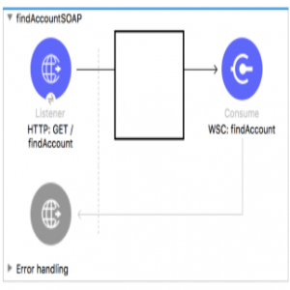

Transform Message

Which RESTful web service request method retrieves the current state of a resource in some representation (usually JSON or XML)



GET

Which RESTful web service request method replaces a resource completely? (If the resources doesn't exist a new one is created)



PUT

A RAML example fragment named BankAccountsExample.raml is placed in the examples folder in an API specification project. What is the correct syntax to reference the fragment?



Example: !include examples/BankAccountsExample.raml

What are four benefits of API portals? (Choose 4)

What is the maximum number of Mule applications that can run in a Cloud Hub Worker?



At most one

What takes data and devices connected with APIs to make them pluggable and to create reusable services?



Application network

What is a method of communication that allows two software systems to exchange data over the internet?



Web Service

What does an API proxy application NOT do?

Determine which response Mule event is allowed to pass through to the API backend service

An HTTP Request operation returns a JSON array of objects. In the Transform Message component, what is the process to convert the array of objects to an array of custom Java Account objects?



Add the Account object metadata to the output and use the drag-and-drop feature to transform the incoming JSON data

What provides info for how to communicate with a software component?



API

What do RESTful web services use?



Standard HTTP protocol

When a REST API is added to the exchange, what is automatically created for it?



API Portal

What are three things an API portal has? (Choose 3)



Auto-generated API documentation



API console



Auto-generated API endpoint that uses a mocking service

Refer to the exhibit: *1 #%RAML 1.0* *2 title: American Flights API* *3 version: 10* *4* *5 /flights: 6 get:* *7 8 /{flight_id}:* *9 10 get:* There is an error in the flight_id resource's GET method. What needs to be done to fix the problem?



Indent the get method under the {flight_id} resource

What is the process to create a connector using REST Connect?



Design the API In Design Center and publish the API to Exchange

When is a connector automatically created?



When a RAML 1.0 API specification is added to the exchange

What application is used for building integration apps that connect systems and consume APIs?



Anypoint Studio

How are multiple conditions used in a Choice router to route events?

To find the FIRST true condition, then distribute the event to the ONE matched route

Refer to the exhibit. This RAML specification includes an XML example that matches the Records data type defined in another RAML file named recordsDataType.raml. Using the Records type, how can this XML example be represented in RAML?

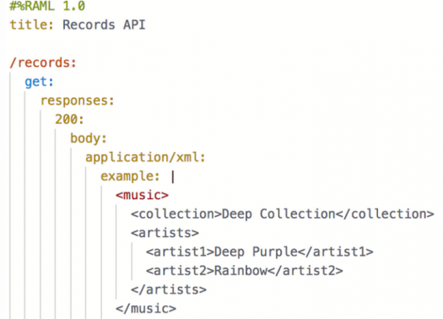

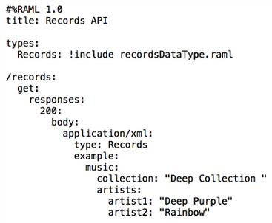

What application is used for designing, documenting, and mocking APIs?

What is the language Mule uses to access, query, and transform event data?



DataWeave 2.0

What does the Mule runtime use to enforce policies and limit access to APIs?



API Manager

API Manager has been configured to enforce an SLA policy and the RAML spec has been updated with the required client_id and client_secret header requirements. The new RAML spec has been published to Anypoint Exchange. What is the next step to gain access to the API?

Request access to the API in Anypoint Exchange

What happens to the attributes of a Mule event in a flow after an outbound HTTP Request is made?

Attributes are replaced with new attributes from the HTTP Request response (which might be null)

A Scatter-Gather processes three separate HTTP requests. Each request returns a Mule event with a JSON payload. What is the final output of the Scatter-Gather?

An array of three JSON payload Objects

An event contains a payload that is an array of Objects. How is the event routed in a Scatter-Gather?

The ENTIRE event is sent to each route and processed in PARALLEL

A Set Variable component saves the current payload to a variable with the name images. What is the DataWeave expression to access the images variable?



#[vars.images] (vars is a DataWeave predefined variable)

What module and operation will throw an error if a Mule event's payload is not a number?

Validation module's Is number operation

A web service implements an API to handle requests to https://acme.com/customers/{state}. A web client makes a request to this API implementation at https://acme.com/customers/CA. What is the correct DataWeave expression to retrieve the value CA?



#[attributes.uriParams.state]

Refer to the exhibits. What happens to this flow when the Validation module's Is not null operation throws an error?

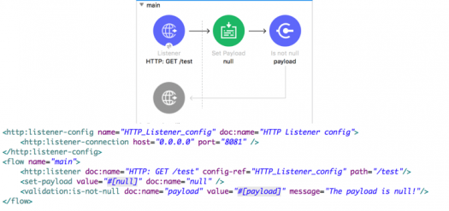

The flow stops processing its Mule event and returns an error message to the HTTP Listener operation

A flow contains an HTTP Listener as the event source. What is the DataWeave expression to log the Content-Type header using a Logger component?

#[“Content-Type: “ ++ attributes.headers.’content-type’]

Refer to the exhibit. The payload [1,2,3] is passed to the Batch Job scope. In Batch_Step_1, a variable named batch1.

StepPayload is set to the current payload. What is the value of the last log message after one batch job completes?

ans.13

Refer to the exhibits. The Set Payload component sets the payload to a Map object (not an Array).

The File Write operation writes out files based on this Map object. How many files are written to the file system when the flow executes?

Refer to the exhibit. What is the object type returned by the File List operation?

Array of Mule event objects.

A Flow Reference component sends a non-empty JSON object payload to another flow named childFlow, which then returns an XML body.

A Flow Reference component saves the payload returned from childFlow to its target attribute named payload.

Refer to the exhibit. What is true about the Mule event's payload at the next event processor after the Flow Reference component?

The payload is the original JSON object.

Refer to the exhibit. What is valid DataWeave code to transform the input JSON payload to the output XML payload?

Option 1

Refer to the exhibit. In the deployable archive's /classes folder, there are two properties files named dev.properties and prod.properties.

The Mule application fails to deploy to CloudHub through Runtime Manager with the following error message. What could be causing this error?

Refer to the exhibit. An event payload contains an unordered array of flight objects, where every object has a price key and a toAirport key.

What is valid DataWeave code to return flights with price under 500, grouped by toAirport in ascending order, with the lowest price first?

Payload filter $.price < 500 orderBy $.price groupBy $.toAirport.

Refer to the exhibits. The Set Payload component sets the payload to a Map object (not an Array). The File Write operation writes out files based on this Map object.

How many files are written to the file system when the flow executes?

ans.0

Refer to the exhibits. The main flow has an On Error Continue scope with type set to HTTP:NOT_FOUND. The Mule application configures globalErrorHandler as its default error handler.

A web client posts a request to the HTTP Listener. The Transform Message component then throws a MULE:EXPRESSION error trying to convert the payload to application/xml.

What response message is returned to the web client?

The MULE:EXPRESSION error's message.

Refer to the exhibits. The main flow has an On Error Continue scope and the private flow has an On Error Propagate scope. A web client makes an HTTP GET request to the HTTP Listener.

The Is number validator in the private flow then throws an error with message "Validate - Payload is an Integer". What response message is returned to the web client?

Error - main flow.

Refer to the exhibits. The private flow has an On Error Propagate scope. In the Configuration global element, default error handler is set to globalErrorHandler.

A web client makes an HTTP GET request to the flow's HTTP Listener. The Is number validator in the private flow then throws an error with message "Validate - Payload is an Integer".

What response message is returned to the web client?

GlobalErrorHandler

Refer to the exhibits. The main flow has an On Error Propagate scope. In the Configuration global element, default error handler is set to globalErrorHandler.

A web client makes an HTTP GET request to the flow's HTTP Listener. The Is number validator then throws an error with message "Validate - Payload is an Integer".

What response message is returned to the web client?

Global Error Handler.

A Mule application has two flows named parentFlow and childFlow. The childFlow begins with an HTTP Listener. A variable is defined in parentFlow,

then an HTTP Request is made to childFlow's HTTP Listener with some headers set. What is the scope of the variable and attributes in the parentFlow after childFlow returns a response?

The variable is accessible. All the attributes passed to childFlow are removed or replaced.

Refer to the exhibits. The main flow has an On Error Continue scope. In the Configuration global element, default error handler is set to globalErrorHandler.

A web client makes an HTTP GET request to the flow's HTTP Listener. The Is number validator then throws an error with message "Validate - Payload is an Integer". What response message is returned to the web client?

Validate - Payload is an Integer

What is NOT part of a Mule 4 event?

outbound prperties.

Refer to the exhibit. What is the correct DataWeave expression for accessing the city Cleveland from the JSON payload?



#[payload[2].city]

Where does a deployed flow designer application run in Anypoint Platform?

Clouhhub Worker.

What is the main purpose of flow designer in Design Center?

To design and Develop fully functional Mule applications in a hosted development environment

In the Database On Table Row operation, what does the Watermark column enable the On Table Row operation to do?

To avoid duplicate processing of records in a database

What is a core characteristic of the Modern API?

API is designed first using an API specification for rapid feedback

According to MuleSoft, what is the Center for Enablement's role in the new IT operating model?

Creates and manages assets to be consumed by of business developers

What statement is part of Mulesoft's description of an application network?

Create reusable APIs and assets designed to be consumed by other business units

What HTTP method in a RESTful web service is typically used to replace a resource completely?

PUT

What is the correct way to format the decimal 20.3844 as a string to two decimal places?

20.3844 as String {format: ".0#"}

What DataWeave 2.0 type can be used as input to a map operation?

Array

What MuleSoft API-led connectivity layer is intended to expose part of a backend database without business logic?

SYSTEM

How can an error scope be configured to catch all errors in the HTTP namespace?

Type: When: #[ error.errorType.namespace == "HTTP" ]

A Mule application has a flow named parentFlow. The parentFlow contains an HTTP Request operation at the end of the flow. The parentFlow also contains a Set Variable operation

right before the HTTP Request operation. What is the scope of the variable to the server receiving the HTTP Request from parentFlow?

The variable is NOT accessible in the server